Sent P^tr@k's De
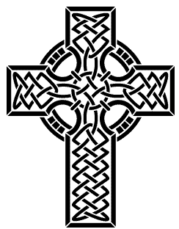
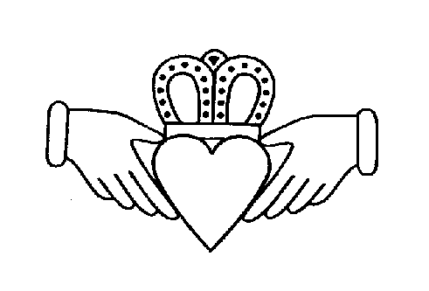
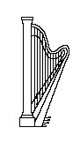
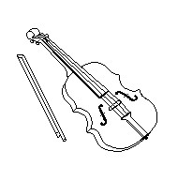
R | G | G | O | L | D | G | R | I | N | H | A | R | P
E | E | ~ | & | M | S | N | E | K | P | L | S | T | U
N | L | M | B | & | N | Q | I | & | * | # | W | # | Q
B | # | R | { | J | K | R | * | S | T | M | B | N | &
O | K | _ | R | # | B | { | # | L | O |  | L | E | M
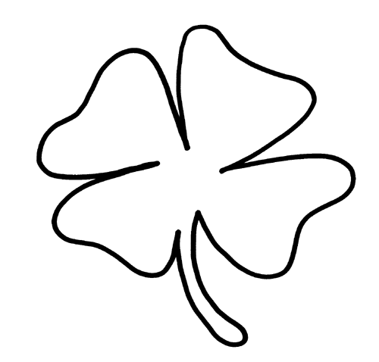  _ | ~ | L | _ | K | ~ | R | _ | ~ | G | # | A | F | R
P | L | D | _ | B | L | # | N | P | O | K | R | # | *
& | T | P | * | T | F | Q | { | R | L | _ | N | D | K
T | # | ~ | N | C | & | N | T | # | D | # | I | L | L
R | K | B | L | ~ | S | # | > | K | L | O | V |  | A
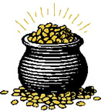  # | P | _ | T | E | T | O | U | * | ~ | L | V | Z | D
  K | K | Q | _ | L | E | L | I | N | P | # | N | C | _
{ | P | _ | R | E | D | R | U | # | D | S | E | N | T

GEL#K | B&NQI | Q&MR*K | P*T | M&J#K
STU | {R#Q | GOLD | ~LVZ | KR*S
~MR_LD | BL~S#> | W#Q | SENT | P#NC
DRU#D | L_K | {RL_ND | F#DLZ | {R_
K~LT#K | KLOV | BLARNI | SNEK | RENBO
K&SL | P&TR#K | L#M#K | HARP | Q_LELI
P*TOGOLD | D_BL#N | KLAD_ | B~LF&ST | GRIN
~NC&NT#D | P_TETO | P_RED | L~PR#K*N

GAELIC | BANSHEE | SHAMROCK | POT | MAGIC
STEW | IRISH | GOLD | ELVES | CROSS
EMERALD | BLESSING | WISH | SAINT | PINCH
DRUID | LUCK | IRELAND | FIDDLERS | EIRE
CELTIC | CLOVER | BLARNEY | SNAKE | RAINBOW
CASTLE | PATRICK | LIMERICK | HARP | SHILLELAGH
POT-O-GOLD | DUBLIN | CLADDAGH | BELFAST | GREEN
ENCHANTED | POTATO | PARADE | LEPRECHAUN

